**DAILY ONLINE ACTIVITIES SUMMARY**

|  |  |  |  |  |  |  |  |  |
| --- | --- | --- | --- | --- | --- | --- | --- | --- |
| **Date:** | 02/06/2020 | | | | | **Name:** | Chethan C K | |
| **Sem & Sec** | 4th SEM ‘A’ SEC | | | | | **USN:** | 4AL18CS017 | |
| **Online Test Summary** | | | | | | | | |
| **Subject** | | N/A | | | | | | |
| **Max. Marks** | | N/A | | **Score** | | | N/A | |
| **Certification Course Summary** | | | | | | | | |
| **Course** | Face Recognition with Deep Learning using Python | | | | | | | |
| **Certificate Provider** | | | Udemy | | **Duration** | | | 3 Hours |
| **Coding Challenges** | | | | | | | | |
| **Problem Statement:**1.Write a C Program to find the leaders in the array.  2.To find the count of subarrays such that each subarray has exactly K distinct  elements. | | | | | | | | |
| **Status:** Completed | | | | | | | | |
| **Uploaded the report in Github** | | | | | YES | | | |
| **If yes Repository name** | | | | | <https://github.com/alvas-education-foundation/chethan_c_k> | | | |
| **Uploaded the report in slack** | | | | | YES | | | |

**Online Test Details:** N/A

**Certification Course Details:**

**Name of the course**: Face Recognition with Deep Learning using Python

**Certificate Provider**: Udemy

Today I went through the three modules of the course that explained about facial imaging and detection.

**Snapshot:**

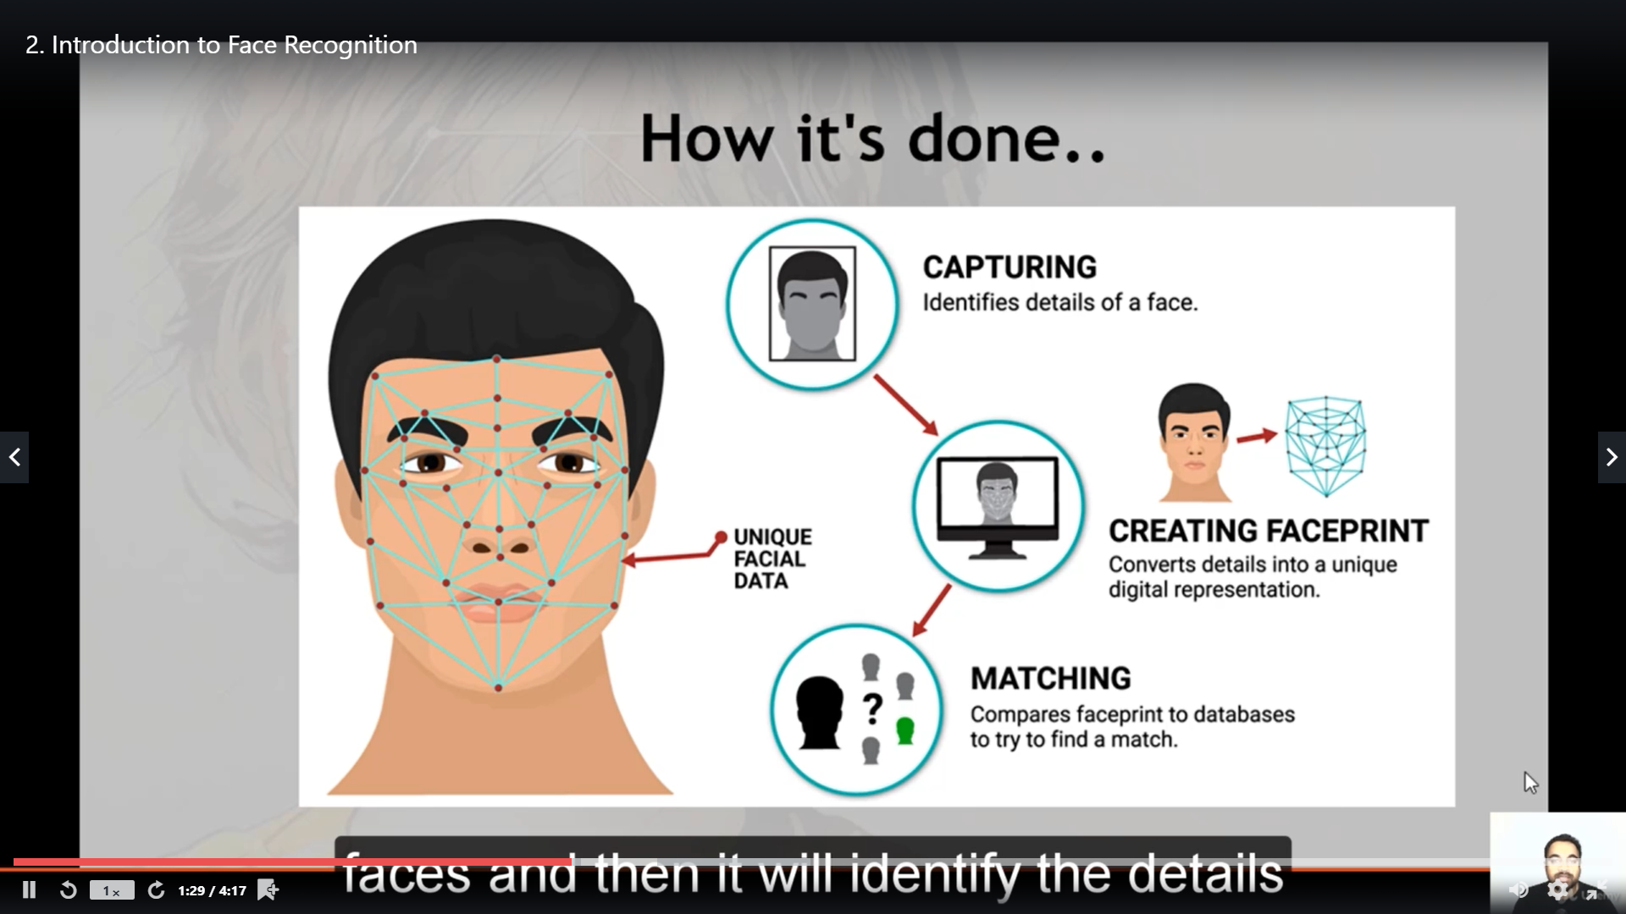

**Online Coding Details:**

Problem 1: Write a C Program to find the leaders in the array.

**Snapshot:**

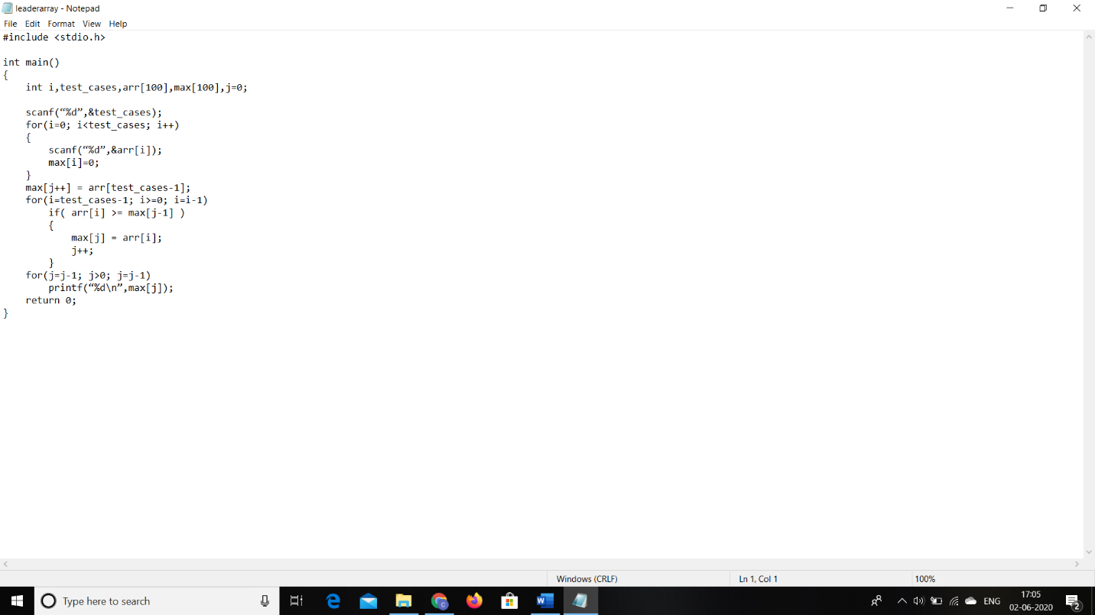

Problem 2: To find the count of subarrays such that each subarray has exactly K distinct elements.

**Snapshot:**

